Report on the activity of non-commercial organization for the period of 2015.

Regional charitable public organization
“Center for Curative Pedagogics”
(full name of non-commercial organization)

119311, Russia, Moscow, Stroiteley str. 17B
(address (location) of the authority , for contacting non-commercial organization)

Interdistrict Inspection Moscow Tax Service ( Russia) №39 , Moscow
(name of registering authority)

OGRN 1027739270900, date of registration 30.06.1999 г.

INN/KPP 7736075657/773601001

Main activity within accounting period (according to the purpose and subject of the activity, determined by charter documents):
1. Curative-pedagogical assistance to children, teenagers, young people with developmental disorder, and to their families.
2. Training of specialists.
3. Social activity.

Tasks have been solved:

- Development and implementation of the programs of curative-pedagogical lessons with children, teenagers and young people with developmental disorder; as well as socio-psychological support for families that bringing up children with developmental disorder.
- Contribution to the development of the system of educational and rehabilitation institutions in Moscow and different regions of Russian Federation, that operate in the sphere of providing assistance to children with developmental disorder
- Accompanying children with developmental disorder in different educational institutions in Moscow and Moscow region; organization of supportive curative-pedagogical sessions; information, organizational and methodic support to specialists whose activity is connected with working with children with developmental disorder in different institutions.
- Sharing the experience of the Center, as well as other experience, including experience of foreign colleagues; organizing and implementation of seminars and advanced training for specialists of educational and rehabilitation institutions and organizations; running of practical lessons and lectures for pedagogical and psychological students; issue and distribution of special literature and others.

Appendix 1
1. Curative-pedagogical assistance to children, teenagers, young people with developmental disorder, and to their families.

Curative-pedagogical assistance in 2015 :

31882 correctional-developmental lessons with children, including:

- 20250 individual correctional-developmental lessons with children
- 8128 group correctional-developmental lessons with children
- 3504 lessons in the integrative tent camp of the Center

*******
- 467 lessons in groups for psychological assistance of the parents
- 1547 consultations, including 584 - initial consultations
- Rehabilitation in the tent camp of the Center – 7 shifts, 737 participants
- Socio-cultural programs:
- Visit to circus, zoo, museums with teenagers with heavy developmental disorders
- Walks with pupils and their parents
- Stage direction in the theater group «Loukomorie»
- Maintenance of the new forms of the integration:
- Individual integrative support in the Center – 58 children
- Support of the integration in specialized classes and groups in regular schools and in groups of preschool facilities – 7 classes, 20 children, including correctional classes – 10 children, inclusive classes – 10 children.

Quantity and entry list of the participants:

1450 pupils, including:
  - 1256 children and teenagers with development disorder having received psychological and pedagogical assistance in the Center
  - 108 young people with developmental disorder, having participated in the project of professional education and prevocational training together with the State budget educational institute in secondary professional education «Technological college № 21»
  - 35 young people, having participated in the program of accompany homestay “Training appartment”
  - 17 young people, having participated in the socio-labor program «The day is not for nothing»
  - 12 young people with developmental disorder, having participated in the project of socio-labor adaptation in ceramic workshop «Peculiar ceramic»
  - 22 young people with developmental disorder, having participated in the project of socio-labor adaptation in carpenter’s workshop «Artel of blissfuls»

Appendix 2

Distribution of pupils by place of residence,
2015, 1450 persons
Moscow West
16%
Moscow East
5%
Moscow North
5%
Moscow Northeast
5%
Moscow Northwest
5%
Moscow Center
7%
Moscow South
10%
Moscow Southeast
5%
Moscow Southwest
22%
Moscow region
15%
Other regions of RF
5%
Moscow West
Moscow East
Moscow North
Moscow Northeast
Moscow Northwest
Moscow Center
Moscow South
Moscow Southeast
Moscow Southwest
Moscow region
Other regions of RF

Appendix 3

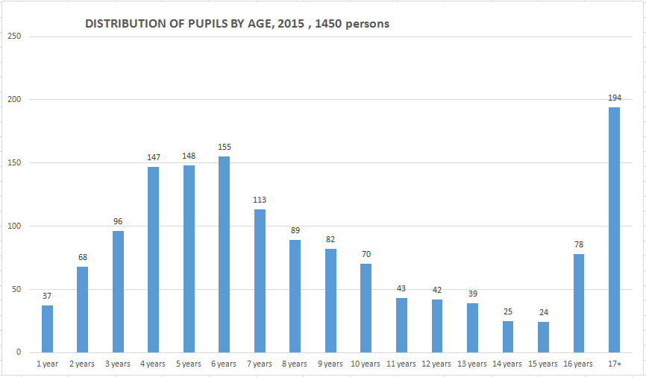
Appendix 4

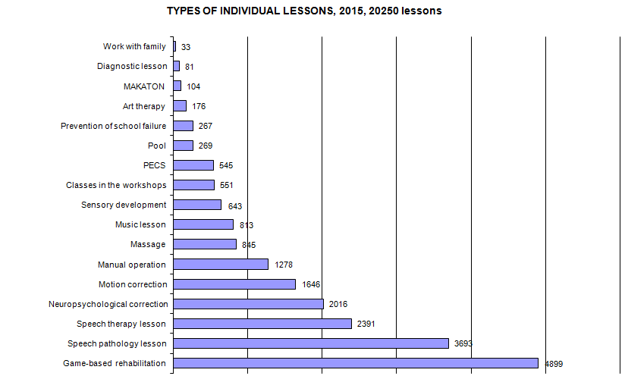
Appendix 5

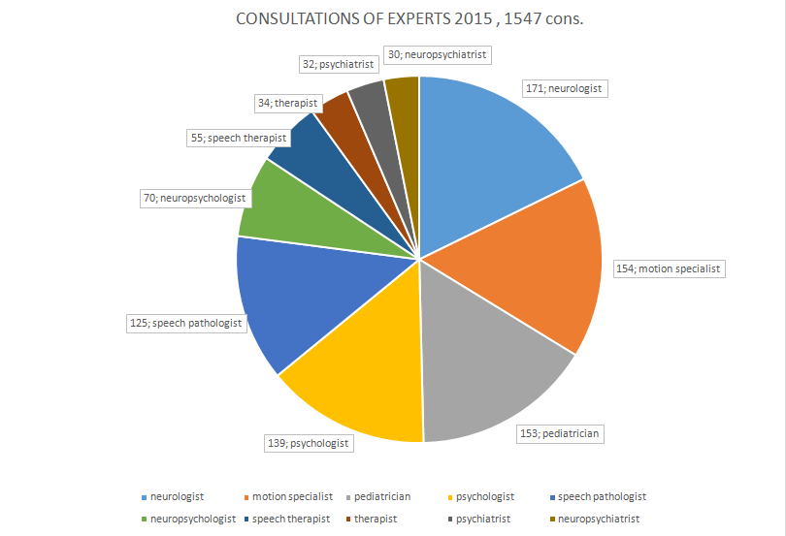

Appendix 6

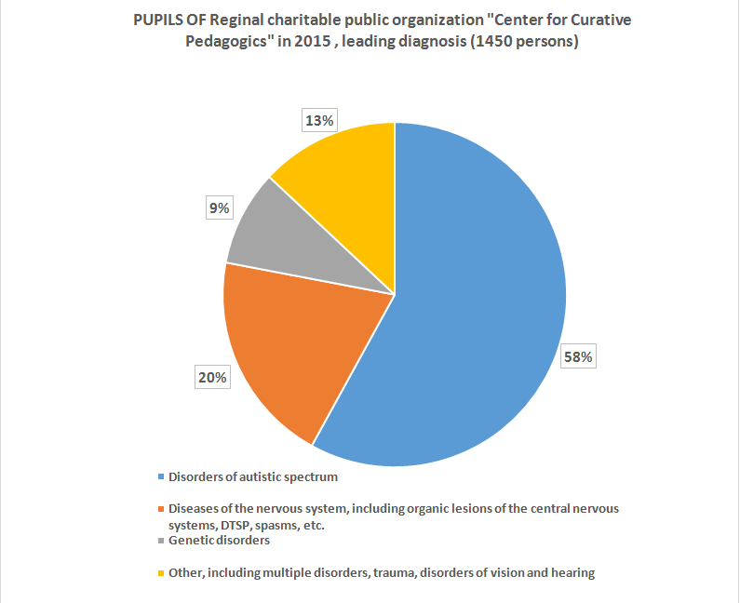

Appendix 7
2. Training of specialists.

Name of the event | Location of the event | Quantity of the events, pcs. | Quantity of the attendees, persons | Quantity of the attendees, per month
 |  |  |  | 01 | 02 | 03 | 04 | 05 | 06 |  | 07 | 08 | 09 | 10 | 11 | 12
Seminars in regions of Russian Federation and abroad | Tula | 1 | 40 |  |  |  |  | 40
 | Vyksa | 4 | 133 |  | 30 | 32 |  | 46 | 25
 | Kirov | 1 | 70 |  |  |  |  | 70
 | Moscow | 3 | 65 |  |  |  |  |  |  |  |  |  | 65
 | Orenburg | 1 | 88 |  |  |  |  | 88
 | Ulan-Ude | 1 | 28 |  |  |  | 28
 | Vyshniy Volochek | 1 | 35 |  |  |  |  |  |  |  |  |  |  |  |  | 35
 | Perm retion, Chusovoj | 3 | 122 | 80 |  |  |  |  |  |  |  |  |  | 45 | 42
 | Almaty, Kazakhstan | 4 | 132 |  |  |  |  | 50 | 28 |  |  |  | 27 | 27
 | Mykhailovsk | 2 | 60 |  |  |  |  |  |  |  |  |  |  |  | 60
 | Vladimir | 3 | 186 |  | 71 |  | 115
 | Astana | 5 | 173 |  |  |  | 47 | 20 | 60 |  |  |  |  | 23 | 23
 | Zhigulevsk | 1 | 37 |  |  |  |  | 37
 | Perm | 1 | 10 |  |  |  |  |  |  |  |  |  |  | 45 | 10
 | Ivanovo | 1 | 40 |  |  |  |  |  |  |  |  |  |  |  |  | 40
 | Valdai | 3 | 100 |  |  |  |  |  | 30 | 28 |  | 42
Total |  | 32 | 1319

Appendix 8
Name of event | Location | Quantity of events, pcs. | Quantity of attendees, persons
Seminars and trainings on the base of the Center | Moscow, participants from RF regions | 27 | 589
Practical workshops for the students (MSUPE, RSUH, MPSU) | Moscow | 48 | 42
Refresher training cousrses | Moscow, participants from RF regions | 6 | 137
Seminars for young specialists and volunteers | Moscow | 33 | 533
Groups of psychological support for parents | Moscow | 467 | 171
Refresher training courses for employees of orphanages | Moscow | 1 | 40
The organization of the functioning of the section at the forum “Every child deserves a family” | Moscow | 6 | 520
Seminars on the base of educational institutions (RSUH, MSUPE, gymnasium ORT) | Moscow | 4 | 432
Forum of the patients with rare diseases | Moscow | 1 | 300
Webinars | Moscow | 2 | 280
III International scientific-practical conference “Inclusive education: results, experience and perspectives” | Moscow | 1 | 120
TOTAL events/ attendees |  | 628 | 4483

Appendix 9
Theoretical and practical classes for the attendees of the refreshing training courses - 6 groups, a total of 137 persons:
- Modern approaches and latest technologies in working with children with limited abilities, Moscow, CCP.
- Specifics of approaches and unconventional methods for working with children with autism disorders, Moscow, CCP.
- author’s trainings and seminars for specialists of different educational and rehabilitation institutions and organizations of the basis of the Center – 27 events, 589 persons
- 15-16 February 2015 – author’s seminar “Sensory integration: diagnosis and correction of children’s disorders“, moderators Ermolaev D., Ratynskaya T.
- 23-24 February 2015 –author’s seminar “First game era – the beginning of the formation of relationships with others and the exploration of self as a tool of cognition of the surrounding world”, moderator Zakharova I.Y.
- 05 March 2015 –author’s seminar “Different points of view on autism”, moderators Dimenstein M., Boyarshinova O.
- 12 March 2015 – informational meeting for parents and specialists, moderators Dimenstein M., Boyarshinova O.
- 19 March 2015 - author’s seminar « Affection and children-parents relations», moderators Dimenstein M., Boyarshinova O.
- 22-24 March 2015 - author’s seminar «Parents and children: first year» 1st seminar of the programm, moderator Zakharova I.Y.;
- 29 March 2015 – author’s seminar «Special child and volunteer in orphan house: how to develop relations and solve the problems of socialization », moderator Legostaeva A.;
- 06-07 April 2015- author’s seminar «Second game era – exploration of physical space and formation of physical borders with the world », moderator Zakharova I.Y.;
- 19 April 2015 - author’s seminar «The formation of speech if it's heavy underdevelopment: command and neuropsychological approaches in the work of a speech therapist», moderators Bitova A.L., Konstantinova I.S.;
- 26-27 April 2015 - author’s seminar « Solutions to specific behavioral children’s disorders : fears, anxiety, aggression, negativism, autostimulation , etc. .», moderators Ermolaev D.V., Ratynskaya T.M.;
- 11-12 May 2015 – author’s seminar « How to help children, adolescents and parents to overcome problems and create good stories: narrative practices in psychological counseling », moderator Moskvichev V.V..;
- 17-19 May 2015 - author’s seminar «Parents and children: first year» 2nd seminar of the program, moderator Zakharova I.Y;
- 25-26 May 2015 - author’s seminar «Third game era – exploration of the inner mental world of their emotions and desires, the development of emotional boundaries with others», ведущие moderator Zakharova I.Y;
- 27 May 2015 – author’s seminar “Neuroreplete – important socio-historical guidelines for future parents, moderator Carla Anauate, professor of the University Uninove (Brasil);
- 18-19 June 2015 - " Music and dance in correctional and therapeutic work with children with developmental disorders ", moderators KonstantinovaI.S., Tikhonova O.A.;
- 15-24 July 2015 –a series of seminars for parents and volunteers “ Accompaniment and support for families with a special child", moderators M. Ostrovskaya, A.L. Bitova;
- 19-20 September 2015 – Basic level of the programm «MAKATON» - method of teaching of communication, moderators Lebedeva E.N., Kibrik A.;
- 24-26 September 2015 г. – author’s seminar «The development of the upper limb function. Preparing hand for writing», moderator Klochkova E..;

Appendix 10
- 27-29 September 2015 - author’s seminar «Parents and children: First year» 3d workshop of the program, moderator Zakharova I.Y;
- 10-11 October 2015 – author’s seminar «Play seriously: the basics of focusing with children and for children», moderator René Veugelers), Holland;
- 24-25 October 2015 – author’s seminar «Preparation for school of children with autism disorders and other developmental disorders», moderators Karanevskaya O., А.Kibrik, Е. Kharlamova;
- 06-08 November 2015 – author’s seminar «On the formation of movements: correctional work with children (and their parents) on the basis of the theory of movement formation by N.A. Bernstein: 1st workshop», moderator Maximova E.V.;
- 20-22 November 2015 – author’s seminar «On the formation of movements: correctional work with children (and their parents) on the basis of the theory of movement formation by N.A. Bernstein: 2nd workshop», moderator Maximova E.V.;
- 27-28 November 2015 – author’s seminar «Methods of speech therapy correction work with severe speech disorders and autism spectrum disorders», moderator Klimontovitch E.;
- 29 November – 01 December 2015 - author’s seminar «Parents and children: first year» 4th seminar of the program, moderator Zakharova I.Y;
- 04-05 December 2015 - author’s seminar «Cooperative play and narrative drawing as methods of correctional work with autistic children», moderator Bayenskaya E.N.;
- 11-13 December 2015 – author’s seminar «On the formation of movements: correctional work with children (and their parents) on the basis of the theory of movement formation by N.A. Bernstein: 3d workshop», moderator Maximova E.V.;
- 20-21 December 2015 – author’s seminar «Neuropsychological approach to working with children with mental retardation and autism spectrum disorder, difficulty of preparation for school and school academic failure», moderators Ratynskaya T., Ermolayev D.
- organization of seminars for specialists of various educational and rehabilitation institutions and associations of Moscow and other Russian cities, other countries (during the year) – 32 events, 1319 people:

Start date of the event | End date of the event | Seminar topic | The moderator of the seminar | Location of the seminar
24.01.2015 | 26.01.2015 | Modern approaches and new technologies in the work with children with developmental disorders | Zakharova,  Jaremchouk | Chusovoi, Perm region
01.02.2015 | 02.02.2015 | Solutions to specific behavioral children’s problems of preschool and primary school age  with the peculiarities of emotional-volitional development | Ratynskaya,  Ermolayev | Vyksa
16.02.2015 | 16.02.2015 | Development of affection. Children with difficulties of self-regulation and behavioral problems | Zakharova | Vladimir
15.03.2015 | 16.03.2015 | Using a neuropsychological approach to children with mental retardation, difficulties with preparing to school and school academic failure | Ratynskaya,  Ermolayev | Vyksa
30.03.2015 | 30.03.2015 | Different methods of working with children with autism spectrum disorders and other developmental disorders | Zakharova | Vladimir
19.04.2015 | 20.04.2015 | The model of assistance to children with disabilities | Antonova E. | Ulan-ude
25.04.2015 | 27.04.2015 | Practical tools in working with families raising children with developmental disorders, including music, dance, play therapy | Antonova, Konstantinova | Astana
27.04.2015 | 27.04.2015 | Various methods of working with children with down syndrome | Bitova A.L. | Vladimir
04.05.2015 | 04.05.2015 | Seminar on speech therapy | Bitova A.L. | Orenburg
07.05.2015 | 11.05.2015 | Trip to Valday (consultation of children and parents) | Bitova A.L. | Valday
11.05.2015 | 12.05.2015 | The model of assistance to children with developmental disorders | Antonova E. Fokina M. | Zhygulevsk, Samara region
16.05.2015 | 17.05.2015 | Music and dance in correctional and therapeutic work with children with development problems | Konstantinova,  Tikhonova | Vyksa
17.05.2015 | 18.05.2015 | Sensory integration: diagnosis and correction of disorders | Ratynskaya,  Ermolayev | Kirov
24.05.2015 | 25.05.2015 | Sensory integration: diagnosis and correction of children’s disorders | Ratynskaya,  Ermolayev | Tula
01.06.2015 | 02.06.2015 | The model of assistance to children with autism spectrum disorders | Karanevskaya,  Legostayeva | Almaty
03.06.2015 | 04.06.2015 | The model of assistance to children with autism spectrum disorders | Karanevskaya,  Legostayeva | Astana
04.06.2015 | 06.06.2015 | Supervision: the analysis of psychological and pedagogical situations | Petrosyan S.E. | Vyksa
07.06.2015 | 08.06.2015 | Sensory integration: diagnosis and correction of disorders | Ratynskaya,  Ermolayev | Astana
20.06.2015 | 22.06.2015 | Sensory integration: diagnosis and correction of disorders | Ratynskaya,  Ermolayev | Almaty
04.09.2015 | 04.09.2015 | Establishing contact with a child with multiple developmental disorders | Zakharova | Fund for helping hospices “Vera”
12.09.2015 | 12.09.2015 | Wordless communication in the system of assistance to children with disabilities | Bondar | CCP for orphan house №8
13.09.2015 | 14.09.2015 | Visiting seminar for organizations in Bryansk | Bitova A.L., Fadina A.K. | Bryansk
19.09.2015 | 20.09.2015 | Techniques of speech therapy correction work with severe speech disorders and autism spectrum disorders | Klimontovitch | Almaty
26.09.2015 | 26.09.2015 | Wordless communication in the system of assistance to children with developmental disorders | Bondar | orphan house №8
01.10.2015 | 02.10.2015 | Scientific-practical conference "autism spectrum disorders and other mental disorders in childhood. Modern approaches and perspectives for inter-institutional cooperation" | Bitova A.L. | Tula, Sovetskaya str. 29
09.10.2015 | 11.10.2015 | Game pedagogy: first and second game eras | Zakharova,  Ryskina | Chusovoi, Perm region
10.10.2105 | 11.10.2015 | Techniques of speech therapy correction work with severe speech disorders and autism spectrum disorders | Klimontovitch | Astana
11.10.2015 | 12.10.2015 | Seminar-supervision on sensory integration | Ratynskaya,  Ermolayev | Almaty
05.11.2015 | 06.11.2015 | Psychological-pedagogical assistance to infants and children of preschool age | Karanevskaya,  Kharlamova | Mikhailovsk, Stavropol region
07.11.2015 | 08.11.2015 | Preparation for school of children with autism spectrum disorders and other disabilities | Karanevskaya,  Kharlamova | Mikhailovsk, Stavropol region
07.11.2015 | 08.11.2015 | Organization of classes and assistance to the children attending the classes with motion disorders | Boyarshinova, Bitova V. | Orenburg
15.11.2015 | 16.11.2015 | Seminar-supervision on sensory integration | Ratynskaya,  Ermolayev | Astana
20.11.2015 | 22.11.2015 | Game pedagogy: second and third game eras | Zakharova,  Ryskina | Chusovoi, Perm region
21.11.2015 | 22.11.2015 | Basic level of the program "MAKATON" | Kibryk,  Lebedeva | Perm
19.12.2015 | 20.12.2015 | Modern methods of special pedagogy and innovative technology in working with children with multiple disabilities in development | Legostaeva | Vyshny Volochek
19.12.2015 | 20.12.2015 | The model of assistance to children with autism spectrum disorders | Konstantinova, Lebedeva E. | Ivanovo

Appendix 11

3. Social activity
Targets:

- Project appraisal and preparation of regulatory acts in the sphere of education and rehabilitation of children with developmental disorders;
- Educational activities, development and implementation of charitable programs in the area of health care, social adaptation and socio-psychological support for children and their families;
- Creating most favorable conditions for developing potential of each child based on individual characteristics of his development;
- Creating models of upbringing and education of children based on an integrative approach.

Main events:

- Fairs with the participation of adolescents and young people, working in a professional and therapeutic workshops of the Center – 30 events;
- Dissemination of methodical and information materials among parents, professionals, governmental and non-governmental rehabilitation centers of Russia and CIS countries, educational authorities and social protection of the Russian Federation. Distributed 23 edition (2132 copies).

- Information and legal support to families raising children with disabilities: 496 legal consultations

- participation in 37 conferences, round table discussions, meetings, regular meetings with representatives of public organizations, educational institutions, government agencies, including meetings in the Federation Council of the Russian Federation, Commission of the FC of Russian Federation on development of civil society institutions, the Council under the RF President on disabled persons, Government of Moscow, the office of the Commissioner for children's rights in Russia, the Synodal Department for Church charity and social service of the ROC, Moscow Mayor's office, the Department for disabled persons of the Ministry of health and social development of the Russian Federation, the Ministry of economic development of the Russian Federation, the representation of the European Union in the Russian Federation, the Department of education of Moscow, the Department of health, Moscow, Public chamber of the Russian Federation, the United Nations Information centre, Institute of correctional pedagogy RAO, the State Duma Committee on civil, criminal, arbitration and procedural legislation, the Department of small and middle business and competition in Moscow.
- participation in other public events -54 events
- cooperation with radio, TV, newspapers, magazines, informing on the activities of the Center - 32 events

The number and structure of participants:

- parents and professionals having received legal advice and support;
- representatives of state bodies of legislative and Executive authorities of the RF, educational and rehabilitation institutions, human rights and charity organizations, organizations of parents of children with disabilities; independent experts and lawyers.

Volunteers of the Regional charitable public organization
“Center for Curative Pedagogics” in 2015

Avvakoumova Marta
Alymova Alexandra
Anokhina Marina
Antonova Ekaterina
Antziber Lada
Arpishkin Lev
Astakhova Svetlana
Babinkova Polina
Babicheva Valentina
Babicheva Cristina
Bagdasaryan Tatyana
Bar Jakov
Baranova Arina
Bartayev Pavel
Basova Vera
Bashta Ekaterina
Bashta Zakhar
Belova Julia
Belokur Victoria
Belostockaja Daria
Belous Victoria
Belyaeva Evgenia
Berezhnaya Alexandra
Berezhnaya Polina
Berezina Anastasia
Beilezon Yuri
Bogdanov Sergey
Bogdanova Julia
Bogorodskaya Larisa
Bolokhontzeva Daria
Bondarenko Tatyana
Borisova Julia
Borovikova Maria
Bocharova Natalia
Boyarshinova Irina
Broushlinsky Ivan
Bryzgalova Camila
Bouralkin Denis
Bourkina Anna
Bourova Valeria
Bykova Marina
Vedernikova Elizaveta
Venyavkin Ilya
Virin Mark
Wissner Paul Oliver
Vlasova Maria
Vlasova Julia
Volosskaya Olga
Vorobieva Victoria
Vsevolozhskaya Sonya
Germanova Lubov
Geruleva Ekaterina
Gireva Natalia
Glazkov Dmitry
Glazkova Oksana
Glatkova Ekaterina
Glatz Toivo
Glouharev Fedor
Glushko Anastasia
Gnedenko Dina
Gnedenko Jana
Goppen Anastasia
Gofman Nadezhda
Grekova Maria
Gracheva Maria
Grigorieva Alexandra
Grineva Julia
Grishina Elena
Gromik Victoria
Grositakaya Anna
Groudkina Ekaterina
Grouzdeva Anastasia
Damanskaya Alina
Desormo Xavier
Derzhalov Dmitry
Derzhalova Svetlana
Derygina Anastasia
Egorov Yuri
Egorova Evgenia
Eliseeva Olga
Emelyanova Svetlana
Ermilova Valentina
Efimiuk Margarita
Zhdanova Anna
Zhoukovskaya Tatyana
Zavidova Ekaterina
Zakharova Angelina
Zoubareva Taisiya
Ivashkina Olesya
Ishenko Julia
Kaboulova Olga
Kazarnovsky Constantine
Kalinkina Ekaterina
Kannounnikov Dmitry
Kapadne Svetlana
Karazhas Tatyana
Karaseva Ekaterina
Katerinich Olga
Kizas Sergey
Kitova Ulyana
Klak Alexey
Klimaeva Anastasia
Knyazhizky Alexander
Kovalev Ivan
Kogan-Lerner Boris
Kogan-Lerner Maria
Kozhemzharova Diana
Kolganova Anastasia
Kolesov Anton
Kolmanovsky Ilya
Kolyaskina Ekaterina
Komarova Marina
Konovalova Alexandra
Korobkov Michail
Koroleva Natalia
Kostiukova Elena
Kotzur Oksana
Kravchenko Tatyana
Krylov Dmitry
Kryukov Evdokim
Koudinova Daria
Kournosova Ludmila
Kourochkin Dmitry
Lavrisheva Julia
Lavrora Alexandra
Lebedev Michail
Lebedev Sergey
Lebedeva Elena
Leshinskaya Janina
Livshits Maria
Lipes Julia
Lisitsin Evgeny
Litavrin Dmitry
Lomova Christina
Lysenko Anastasia
Lvov Zakharia
Makeeva Alena
Maleshina Olga
Mamonova Svetlana
Marasinova Dana
Martynov Alexey
Martynova Natalia
Masolikova Anna
Medvedev Dmitry
Medved Svetlana
Melamed Alexander
Menyailova Olga
Mesheryakova Ekaterina
Miambo Amalia
Mikhailichenko Michail
Mikhailova Anna
Mikhael Hanna
Mishin Dmitry
Mokvopolova Jeanne
Morzhina Alexandra
Moroghina Natalia
Morshneva Olesya
Mouratova Arina
Mourzina Tatyana
Nedorgeeva Olga
Nikitin Alejandro
Nikolaeva Olga
Novikova Victoria
Novodvorskaya Liza
Novokhatskaya Vera
Oleyinikov Alexander
Olshanskaya Ulyana
Onishenko Alexandra
Orlinkova Marianna
Orlov Fedor
Osmanova Diana
Ostrovskaya Irina
Oskin Michail
Parshina Tatyana
Perova Oksana
Petrukhin Grisha
Pisarevskaya Anna
Platonov Alexey
Poletayeva Evgenia
Polouyanova Elena
Pomazan Maria
Prybylova Tatyana
Prymakov Petr
Pryshep Yuri
Proudovskaya Natalia
Prouss Eugene
Proushina Ludmila
Radyghina Lubov
Rasskazov Alexander
Ratouri Oksana
Ringer Anna
Rozhansky Ivan
Rouzavin Ivan
Sablina Lada
Salembo Maria
Samsonov Ivan
Sarafanov Kirill
Satarova Ekaterina
Sevasteev Semen
Sevasteeva Rita
Semenova Anna
Semenova Vasilisa
Sergeyev Boris
Simakova Elena
Smirnova Daria
Соколова Наталья
Sokolova Natalia
Solilova Victoria
Sorokina Svetlana
Soukhov Vasily
Soushko Anastasia
Syrkin Grigory
Talashova Irina
Tezikova Natalia
Timoshenko Olga
Titova Valentina
Titova Margarita
Titova Ekaterina
Tonkova Anna
Torkounova Natalia
Trayanovskaya Olga
Tretiakova Valentina
Troushina Mila
Urinovskaya Veronika
Fedoseev Nikita
Feldberg Olga
Filatova-Shnol Anna
Filimonova Olga
fon Ozen Birgit
Frolova Alexandra
Khavkoun Igor
Khait Margarita
Khait Ronen
Khakamova Anna
Khanova Julia
Khloptsev Andrey
Kholodova Olga
Tsareva Anastasia
Tsatouryan Andrey
Tsatouryan Asya
Tsatouryan Karen
Tsiboulski Alisa
Chashnik Leonid
Chernysheva Olga
Chizhikova Elizaveta
Chirikova Alexandra
Chirkova Elizaveta
Choumakova Maria
Shalnova Anastasia
Sharma Hitash
Shengeliya Vera
Sher-Kozhouhova Natalia
Shyrokova Ekaterina
Shlepina Maria
Shmelev Alexander
Shelkova Tatyana
Tshepilov Sergey
Yusova Tatyana
Yakovleva Polina
Yakovleva Shulamith
Jakoubova Maria
Jasyr Andrey

Benefactors of the Regional charitable public organization
“Center for Curative Pedagogics” in 2015

Agapova D.A.
Akimova E.G.
Andriukov I.B.
Antipina O.A.
JSC “KPMG”
JSC “MEDIA ROOM”
JSC “Sberbank Technologies”
JSC “Bank Russian Standard”
JSC Unicredit bank
Baklazhayev I.A.
Baryshnikov S.K.
Belousova J.V.
Belyaikina N.V.
Bogoloubov D.A.
Borzhyh A.M.
Borisova A.N.
Bramli Emi
Bournyasheva O.U.
CF “Absolute-help”
CF “Vmeste detyam”
CF “Vykhod”
CF “Dar”
CF “Joint”
CF “Druzia”
CF “Mozaika Schastya”
CF "Naked Heart"
CF “OMK – Uchastie”
CF “So-edinenie” support fund for deaf and blind
CF “Terevinf”
CF “Fund of food Rus”
CF “I am”
CF “Jeremy Jacka Fund”
CF PJSC Sberbank "Vklad v budushee"
CF for children "Detskie Domiki"
Varlamov P.A.
Vladimirova E.A.
Volozh A.U.
Vorobyev S.V.
Vousatova E.D.
Gavrilenya A.A.
GBOU Gymnasium N 1540
Gessen M.A.
GIS-ASUproject
Nash Xleb Bakery Group of companies
Goloshapova P.V.
Goncharov R.S.
Gora M.A.
Grigorenko O.V.
Green Michael
Grishaev A.A.
Danone Group of companies in Russia
Department of social protection of population, Moscow city
Derevyankin T.V.
Evseeva A.
Egorov D.A.
CJSC "IFDK"
CJSC “First Specialized Depositary ”
Zosimova T.S.
Ivanov I.V.
Internet shop SAND STOL
Kanevsky A.V.
Karachourina I.A.
Kasterina O.V.
Cafe «Prime»
Cafe "Readymade"
Kashirskaya E.V.
Kidzania
Kiselev D.E.
Club for all family “Rimambel”
Kozhemyakina M.A.
Kozlov S.A.
Public relations Committee of the government of Moscow
Komolov A.I.
Korobkov M.I.
Corporation “Chevron Neftegaz Inc.”
Kriuchkova N.A.
Kouznetzova T.A.
Koulakov K.S.
Lavrentiev U.V.
Laptev A.S.
Leontiev A.P.
Lieberman M.E.
Magaz A.A.
Mamadjanova A.
Matiushin A.S.
Merkoulova E.
The Ministry of economic development RF
Monakhov E.A.
IPO – Primary trade union organization of employees and students of MSPU RPO – MCO of Trade union of educators
IPO “Center of study of the issues of family and childhood”
Morev D.V.
Music band of Peter Nalitch
Mouchamedzariphova J.A.
Myasnikova E.O.
Nepryakhin N.Y.
Novard
OJSC «Detsky mir»

All-Russian public movement “Civil dignity”
OJSC “”Wintershall Russland GMBH” Germany filial
OJSC “Polymerteplo Group”
OJSC “Caravella” (Logopark Development)
OJSC “Casting Technology”
OJSC “Kinomaster”
OJSC “Lady” (Barbershop)
OJSC “Lekor +”
OJSC “Liliputplayhomes”
OJSC “Medtronic”
OJSC “Mehkomplekt”
OJSC “Peredovye Platezhnye Reshenya”
OJSC “Procter & Gamble”
OJSC “Samy Sok!”
OJSC “Splat-Cosmetica”
OJSC “Texnologii budushhego”
OJSC “Fenka”
OJSC “Ernst &Young”
OJSC “Deutsche Bank”
OJSC “Megaproryv”
Oroudzhov R.R.
Ostrovskaya I.V.
Oshepkova K.A.
Pavlova L.A.
PJSC “Megafon”
PJSC “MTS”
PJSC “Sberbank”
Paperny TAM
Parovoziya
Bakery “”Dashiny pirozhki”
Pivovar R.E.
Pipko N.D.
Pisemsky A.M.
Users of “Global Networks”
Popova E.A.
Embassy of Germany
Embassy of France
Potolova T.I.
Prishep Y.M.
РА Action
Revoutskaya A.
Restaurant “45th parallel”
Reutskaya Y.A.
Sazhina I.S.
Samsonova V.G.
Svetakov A.A.
Svirin G.A.
Sidorov V.V.
Simakov V.E.
Smirnov V.A.
Sofianos Panagiotis
The Union of specialists in the field of mental health
SPB CO “Perspektivy”
Stepanchenko I.S.
Stepichev A.L.
Insurance group “MAX”
Striukov D.
Soubkhankoulov R.Z.
Theater alliance TOM Golomazova
Terekhova A.D.
Timakov I.A.
Tiounov V.I.
Torbas I.N.
HOA “Zagorskogo”
Toupikina O.V.
Tourchaninova N.A.
Participants and guests of charitable events in favor of CPP
Fedoseeva G.A.
Branch Sagitus in Moscow
Filippova S.M.
The Foundation for children “Alexander”
French lycee Alexandre Dumas
Khazova Y.V.
Kharitonova A.E.
Khripko E.A.
Tsaturyan G.K.
Tsaturyan K.A.
Individuals through the service SMS-donation
Yandex money, Blago.ru, boxes for collecting donations
Shishelev M.N.
School-internat Absolute
ExxonMobile Russian Inc. Moscow representative
Erlich E.E.
Yusova E.V.
ABBYY
Action for Russia's Children (ARC)
Aecom
Bread for the World – Protestant Development Service
Bureau international Catholique de l’Enfance (BICE)
Charitable Foundation for support and development of philanthropy
Delloitte
DPD
European Commission
Foerderkreis Iwanushcka e.V.
Järfälla Pingstförsamlung Aspnäskyrkan
Jewish Agency for Israel
Kellogg Rus LLC
Marriott Moscow
Moskva-Acceuil

